EXP NO : 5
ARDUINO BASED MANUAL ELECTRONIC COUNTER USING PROTEUS
AIM: To write an Embedded C program for Manual Electronic counter using Arduino IDE and Proteus
SOFTWARE REQUIRED:
- Proteus 8 software
- Arduino IDE
PROGRAM :
int x0,x1,x2,x3,x4,x5,x6,x7,x8,x9;
int delay_time=200;
void setup() {
pinMode(12, INPUT_PULLUP);
for(int i=1;i<=7;i++)
pinMode(i,OUTPUT);
}
void loop() {
int sensorVal = digitalRead(12);
if (sensorVal == LOW) {
x0=true;
}
while(x0){
zero();
if (digitalRead(12)==LOW){
x1=true;
x0=false;
delay(300);
}
}
while(x1){
one();
if (digitalRead(12)==LOW){
x2=true;
x1=false;
delay(300);
}
}
while(x2){
two();
if (digitalRead(12)==LOW){
x3=true;
x2=false;
delay(300);
}
}
while(x3){
three();
if (digitalRead(12)==LOW){
x4=true;
x3=false;
delay(300);
}
}
while(x4){
four();
if (digitalRead(12)==LOW){
x5=true;
x4=false;
delay(300);
}
}
while(x5){
five();
if (digitalRead(12)==LOW){
x6=true;
x5=false;
delay(300);
}
}
while(x6){
six();
if (digitalRead(12)==LOW){
x7=true;
x6=false;
delay(300);
}
}
while(x7){
seven();
if (digitalRead(12)==LOW){
x8=true;
x7=false;
delay(300);
}
}
while(x8){
eight();
if (digitalRead(12)==LOW){
x9=true;
x8=false;
delay(300);
}
}
while(x9){
nine();
if (digitalRead(12)==LOW){
x0=true;
x9=false;
delay(300);
}
}
}
/* ===== 7 Segment Functions ===== */
void zero(){
digitalWrite(1,HIGH);
digitalWrite(2,HIGH);
digitalWrite(3,HIGH);
digitalWrite(4,HIGH);
digitalWrite(5,HIGH);
digitalWrite(6,HIGH);
digitalWrite(7,LOW);
}
void one(){
digitalWrite(1,LOW);
digitalWrite(2,HIGH);
digitalWrite(3,HIGH);
digitalWrite(4,LOW);
digitalWrite(5,LOW);
digitalWrite(6,LOW);
digitalWrite(7,LOW);
}
void two(){
digitalWrite(1,HIGH);
digitalWrite(2,HIGH);
digitalWrite(3,LOW);
digitalWrite(4,HIGH);
digitalWrite(5,HIGH);
digitalWrite(6,LOW);
digitalWrite(7,HIGH);
}
void three(){
digitalWrite(1,HIGH);
digitalWrite(2,HIGH);
digitalWrite(3,HIGH);
digitalWrite(4,HIGH);
digitalWrite(5,LOW);
digitalWrite(6,LOW);
digitalWrite(7,HIGH);
}
void four(){
digitalWrite(1,LOW);
digitalWrite(2,HIGH);
digitalWrite(3,HIGH);
digitalWrite(4,LOW);
digitalWrite(5,LOW);
digitalWrite(6,HIGH);
digitalWrite(7,HIGH);
}
void five(){
digitalWrite(1,HIGH);
digitalWrite(2,LOW);
digitalWrite(3,HIGH);
digitalWrite(4,HIGH);
digitalWrite(5,LOW);
digitalWrite(6,HIGH);
digitalWrite(7,HIGH);
}
void six(){
digitalWrite(1,HIGH);
digitalWrite(2,LOW);
digitalWrite(3,HIGH);
digitalWrite(4,HIGH);
digitalWrite(5,HIGH);
digitalWrite(6,HIGH);
digitalWrite(7,HIGH);
}
void seven(){
digitalWrite(1,HIGH);
digitalWrite(2,HIGH);
digitalWrite(3,HIGH);
digitalWrite(4,LOW);
digitalWrite(5,LOW);
digitalWrite(6,LOW);
digitalWrite(7,LOW);
}
void eight(){
digitalWrite(1,HIGH);
digitalWrite(2,HIGH);
digitalWrite(3,HIGH);
digitalWrite(4,HIGH);
digitalWrite(5,HIGH);
digitalWrite(6,HIGH);
digitalWrite(7,HIGH);
}
void nine(){
digitalWrite(1,HIGH);
digitalWrite(2,HIGH);
digitalWrite(3,HIGH);
digitalWrite(4,HIGH);
digitalWrite(5,LOW);
digitalWrite(6,HIGH);
digitalWrite(7,HIGH);
}

OUTPUT :
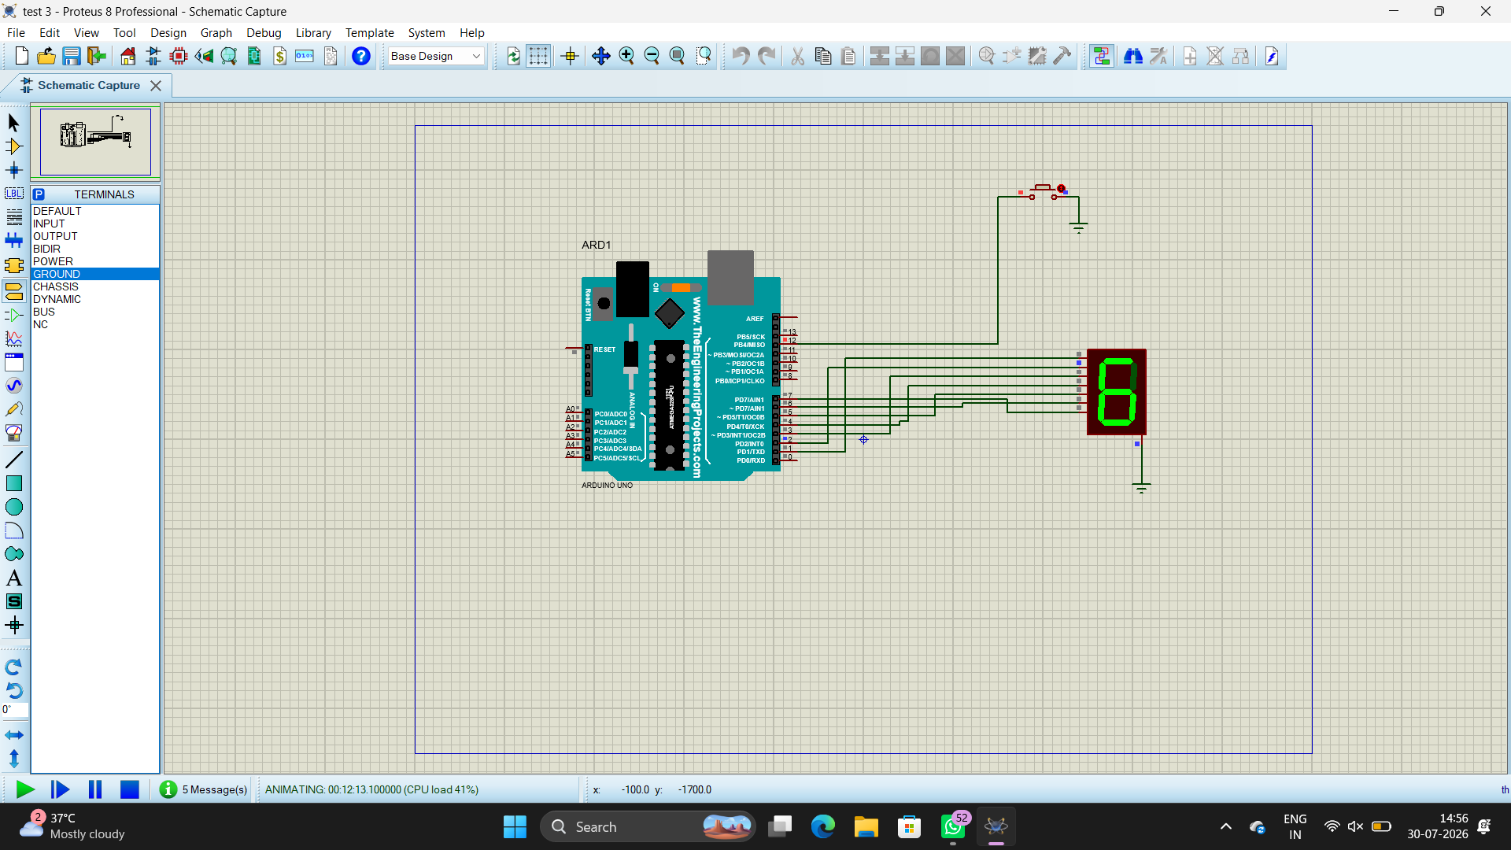
RESULT :
Thus the program has been successfully verified and executed

